Custom Training

Day 11

**Power BI**

It is used to create reports based on data.

PBI Services: To publish reports for other people to view.

PBI Mobile: To have a mobile view of the reports.

We can create reports of well-enriched data, for that we need to transform the data.

Power Query: It is used to transform the data in Power BI. It is also present in other Microsoft services.

Dashboard: Key points of all reports in a single view.

Power Query Editor: M(Mashup Query) Language is used in the backend.

Manage Parameters: For connection, we can create parameters, so that we can change the source environment/connection.

Transformations:

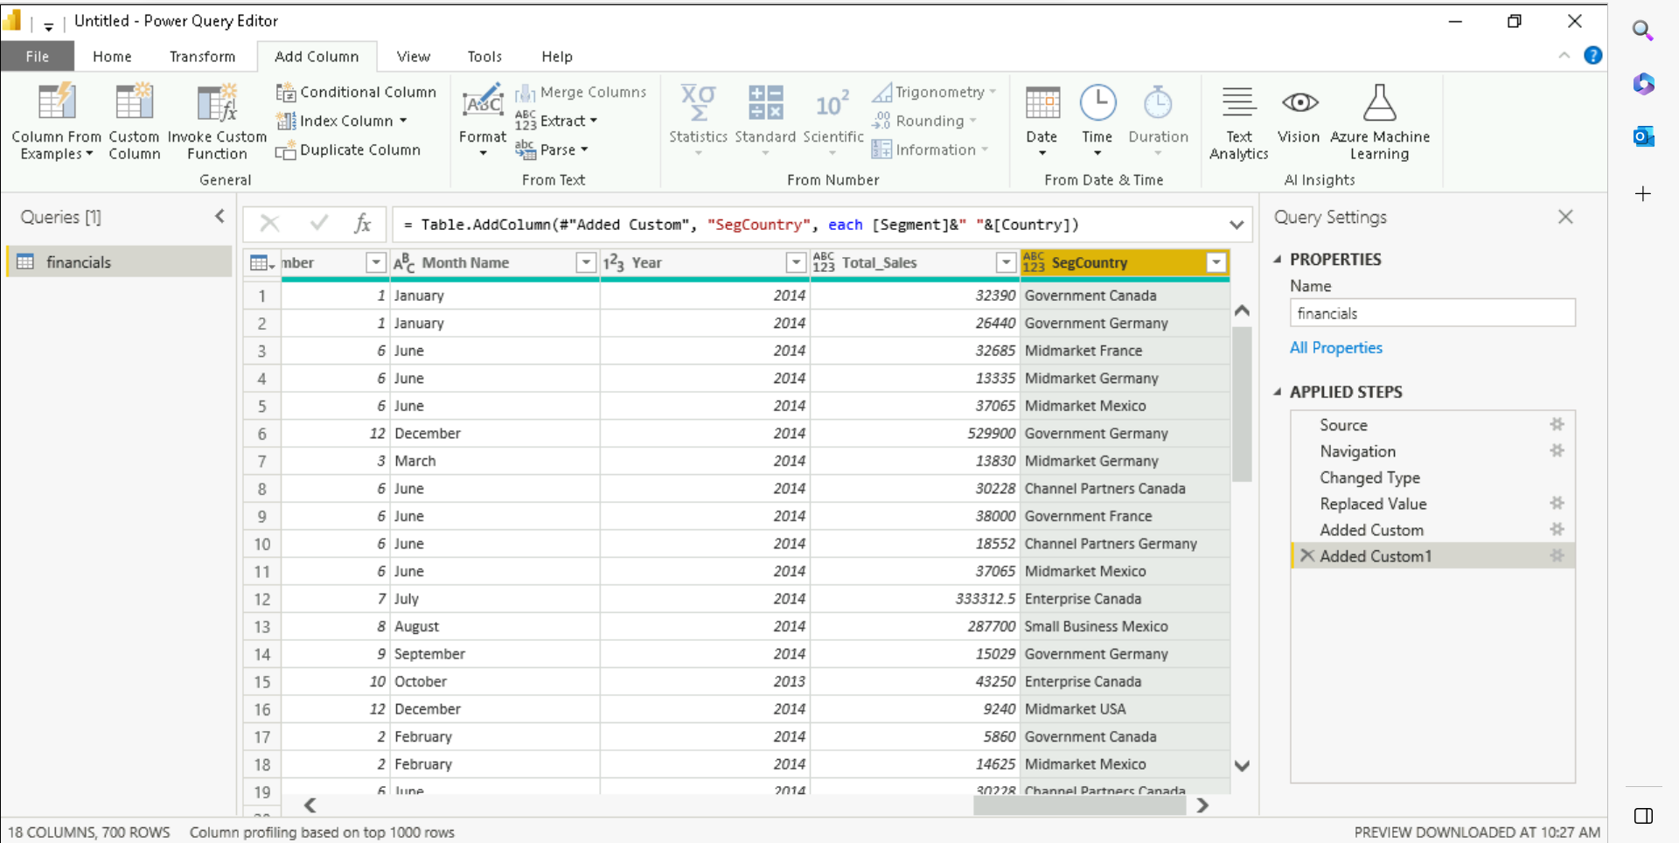

Report Creation:

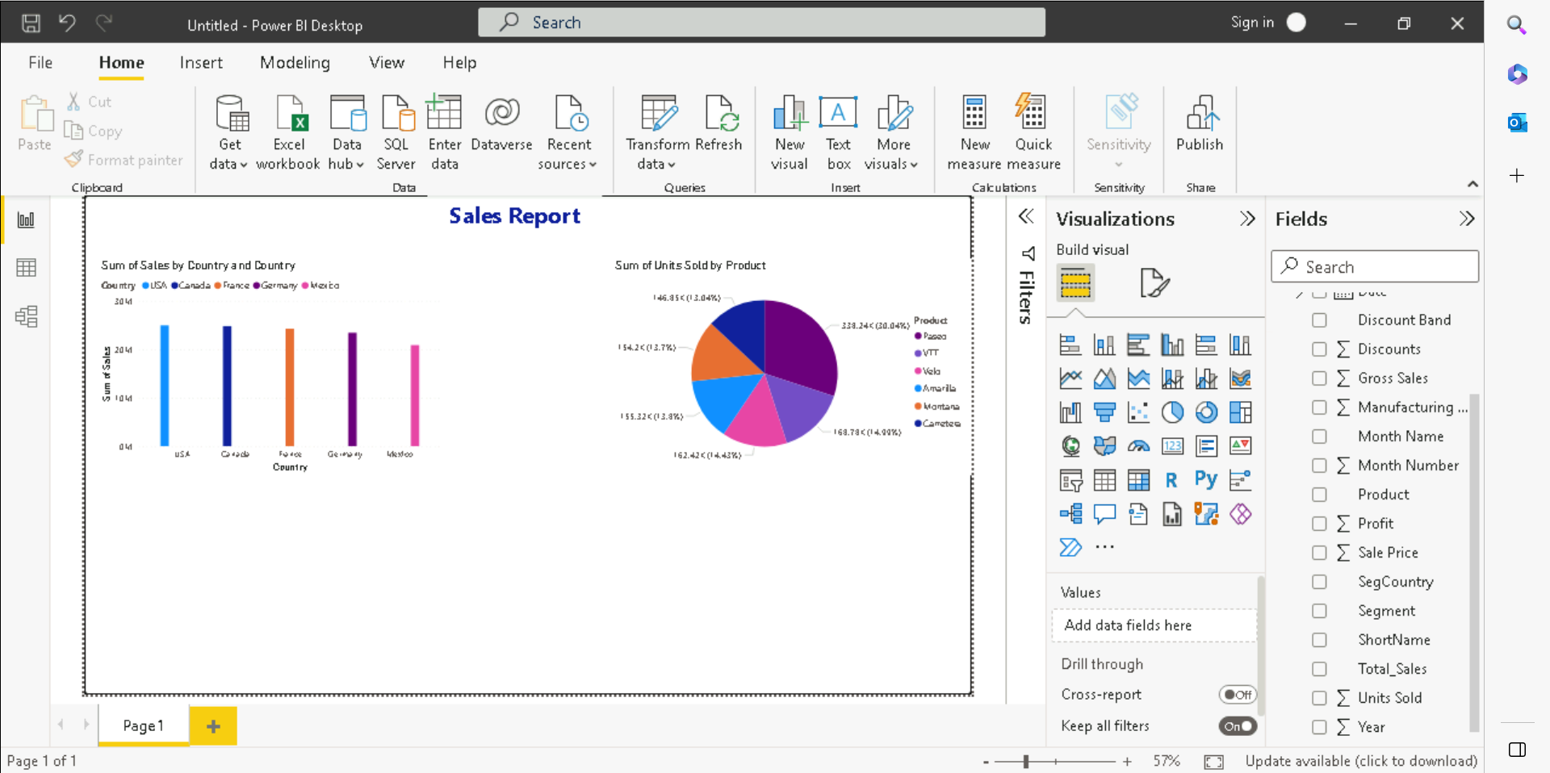

Parameters: To change the data source or to make the data source path dynamic we can create parameters so that different teams can give their requirement specific path.

The number of columns and type should be same only rows can be different otherwise the reports won’t work. 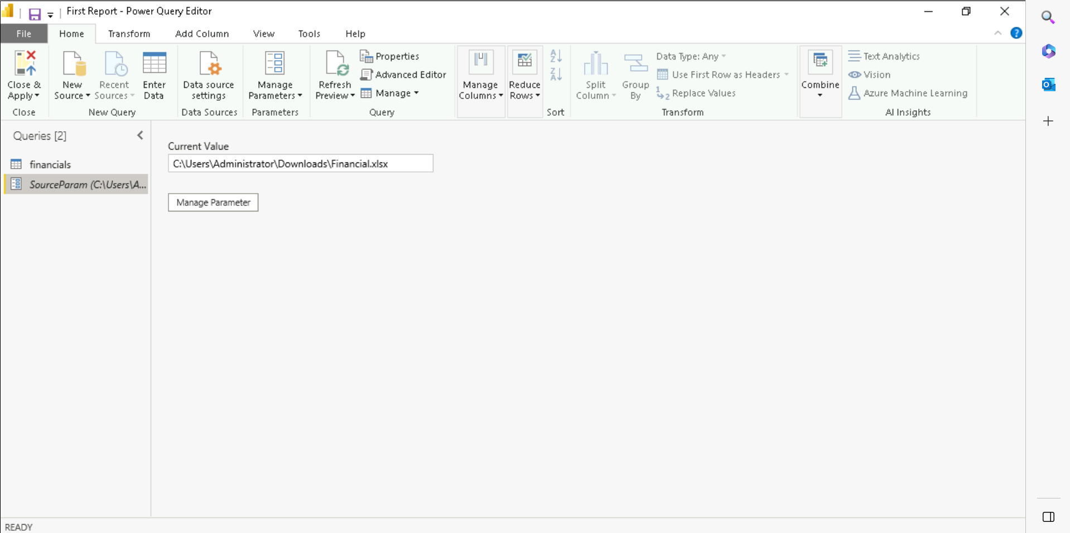

Filters: Used to filter data based on some requirement. Three types:

1. Visual Level
2. Page Level
3. Report Level

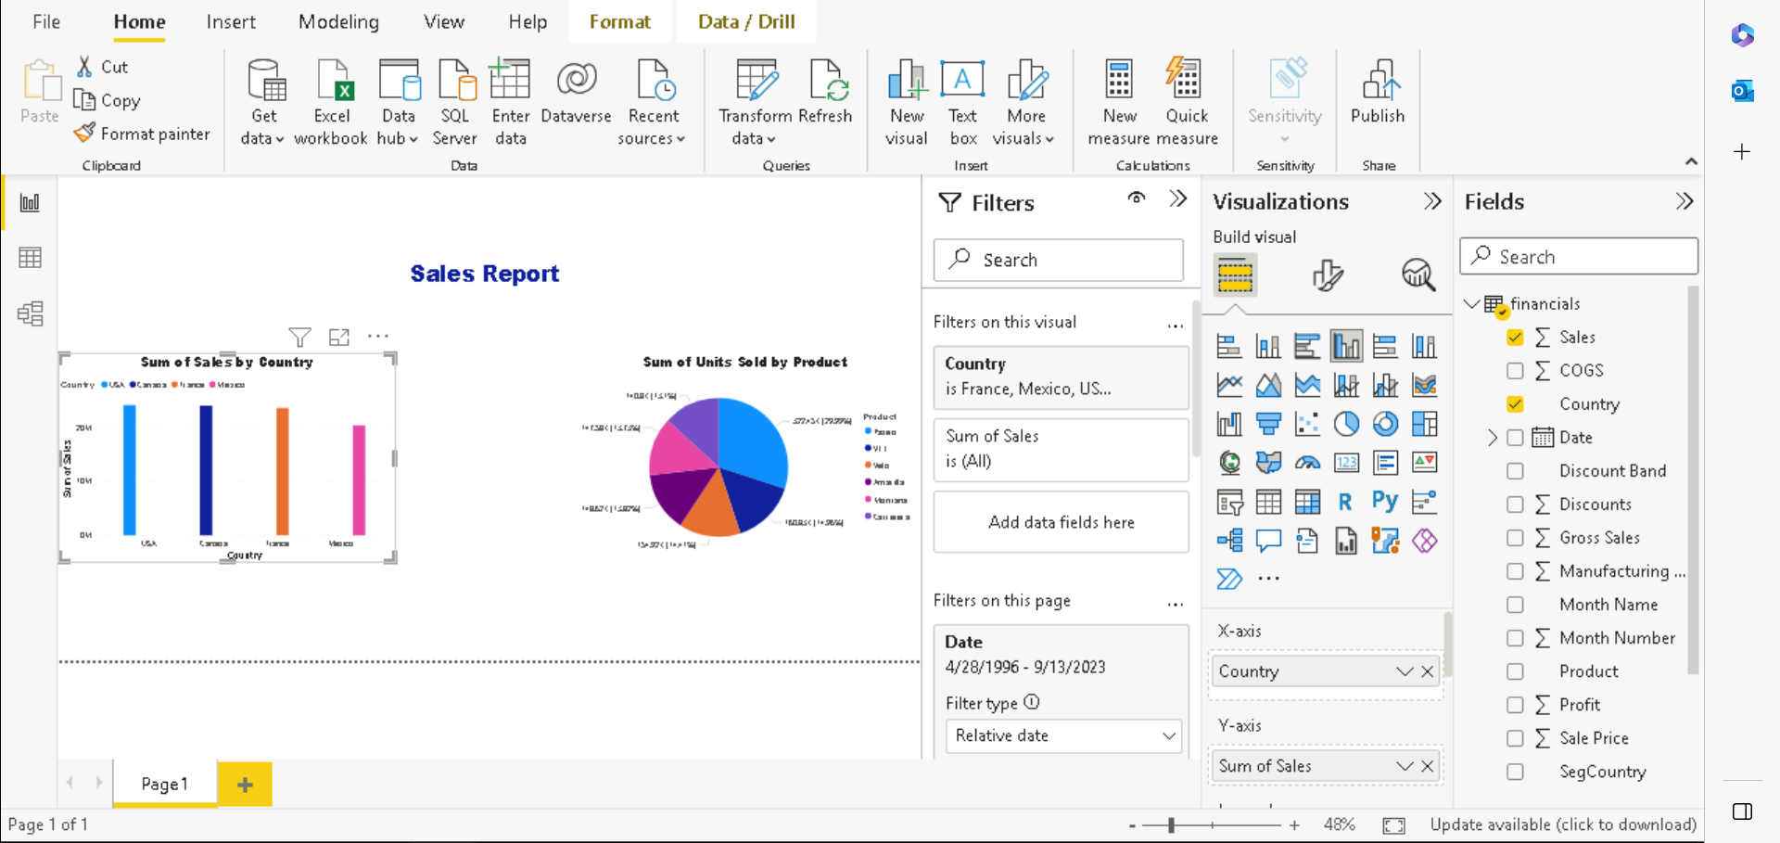

Slicer: Applies the filter on the overall report and increases user interactivity.

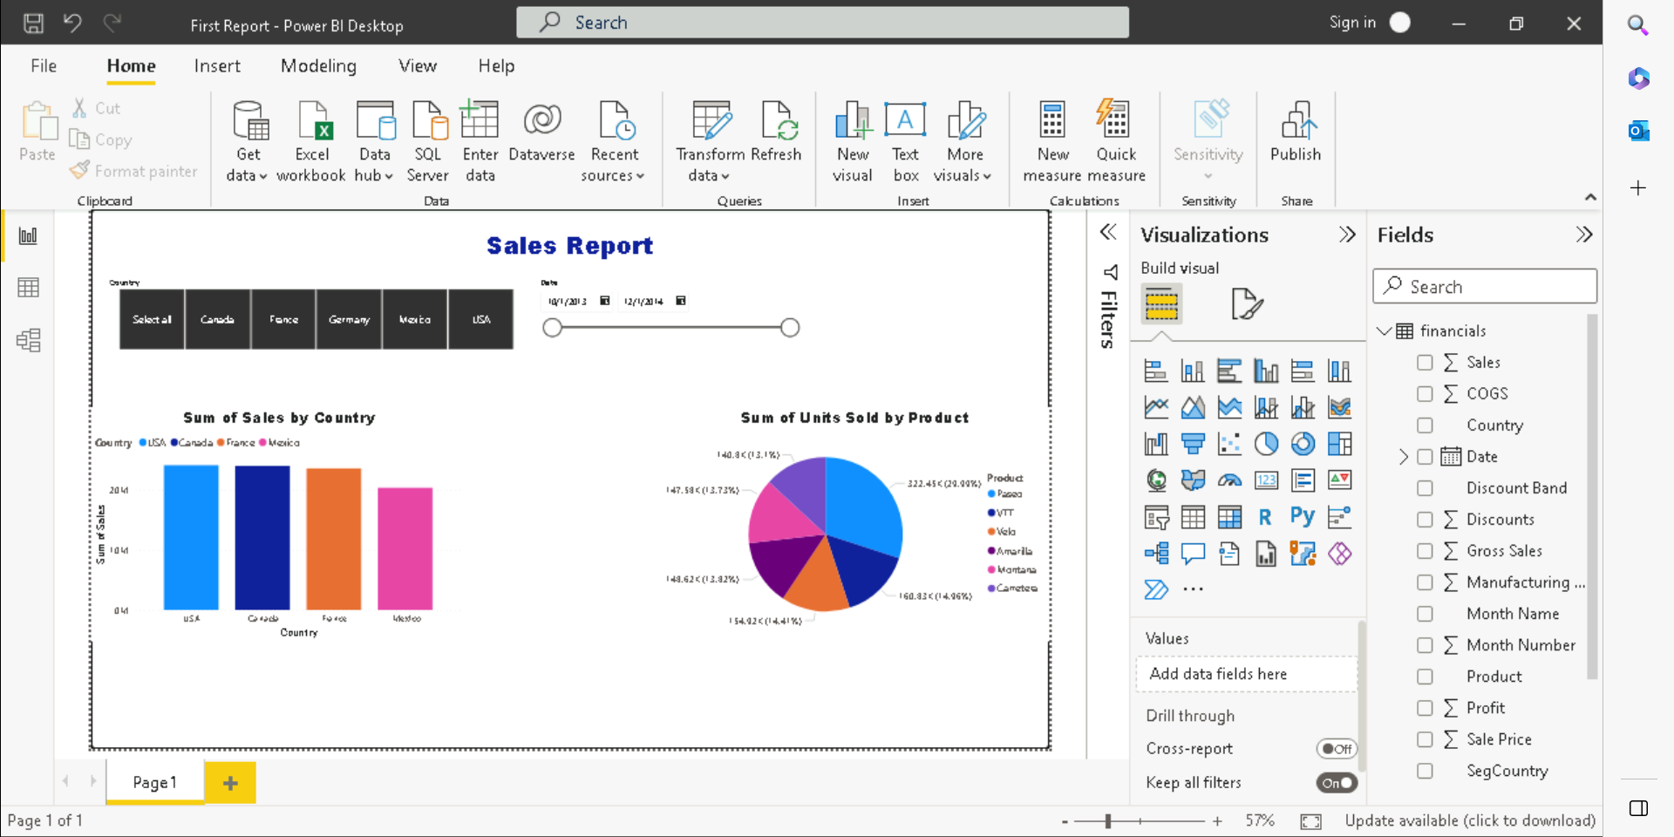

Measures: Two types:

1. Implicit Measure: PowerBi recognizes the columns of numeric type that are known as implicit measure.
2. Explicit Measure: User-defined measures. Uses DAX(Data Analytics Expression).

Calculated columns create overhead by taking space in the memory. Hence we prefer measures because it calculates at runtime.

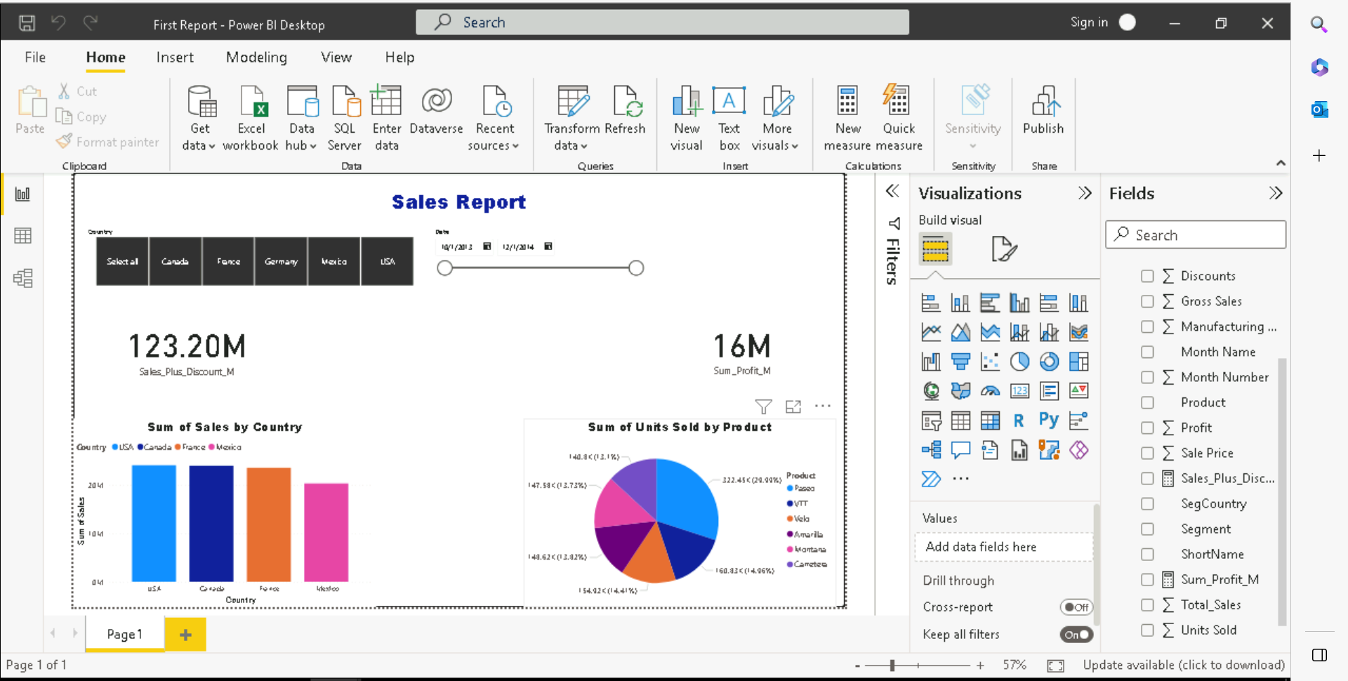

Security:

Show selected things to different level of users.

RLS(Row Level Security): Create groups to show selected data.

